1 Swing components

* 1. AWTAccumulator

* Bấm 10 + 56

* 1. SwingAccumulator

* Bấm 10

* Bấm 16

1. Organizing Swing components with Layout Managers

2.1.Code

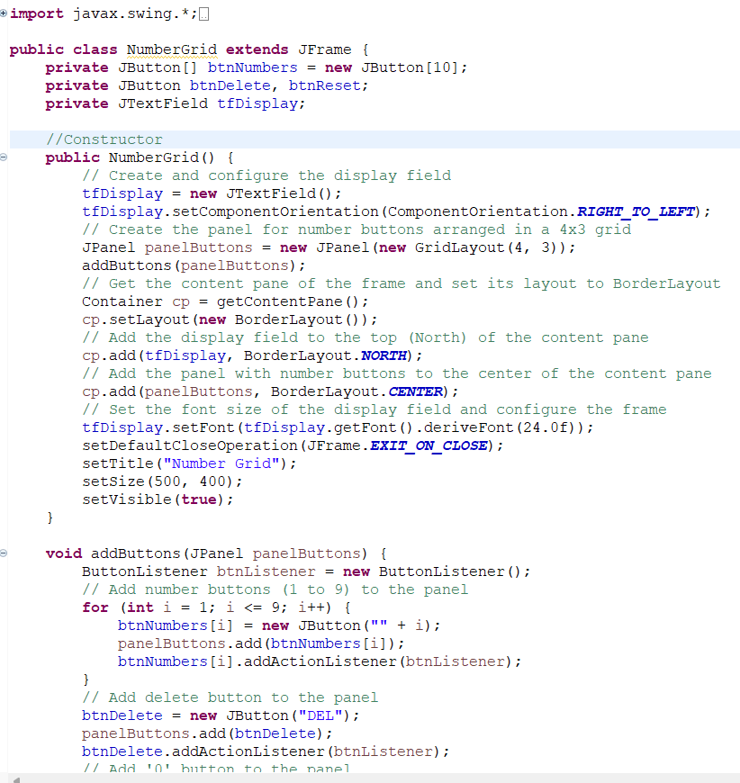

2.2 Demo

- Demo buttons 0-9

-Demo Delete button

-Demo C button

1. JavaFX API
   1. Class Painter

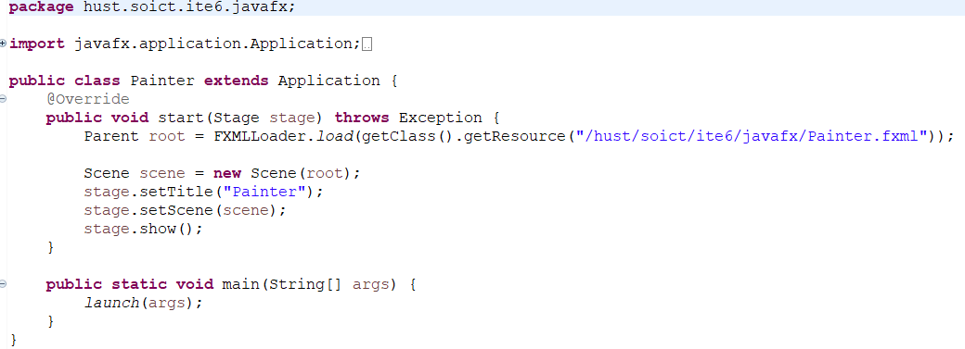

* 1. Class Painter.fxml

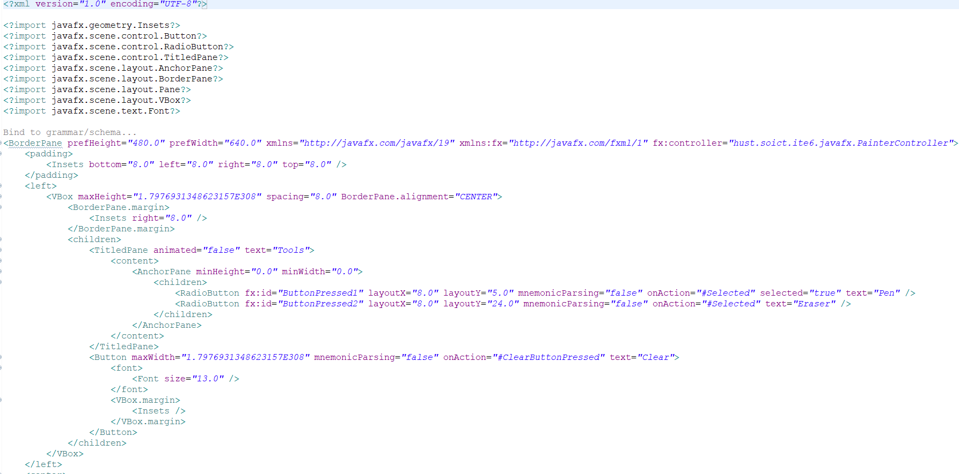



* 1. Class PainterController

* 1. Demo
* Use Pen

* Use Eraser

* Clear

1. Create a graphical user interface for AIMS with Swing
   1. Create class StoreScreen

* 1. Create class MediaStore
  2. Demo

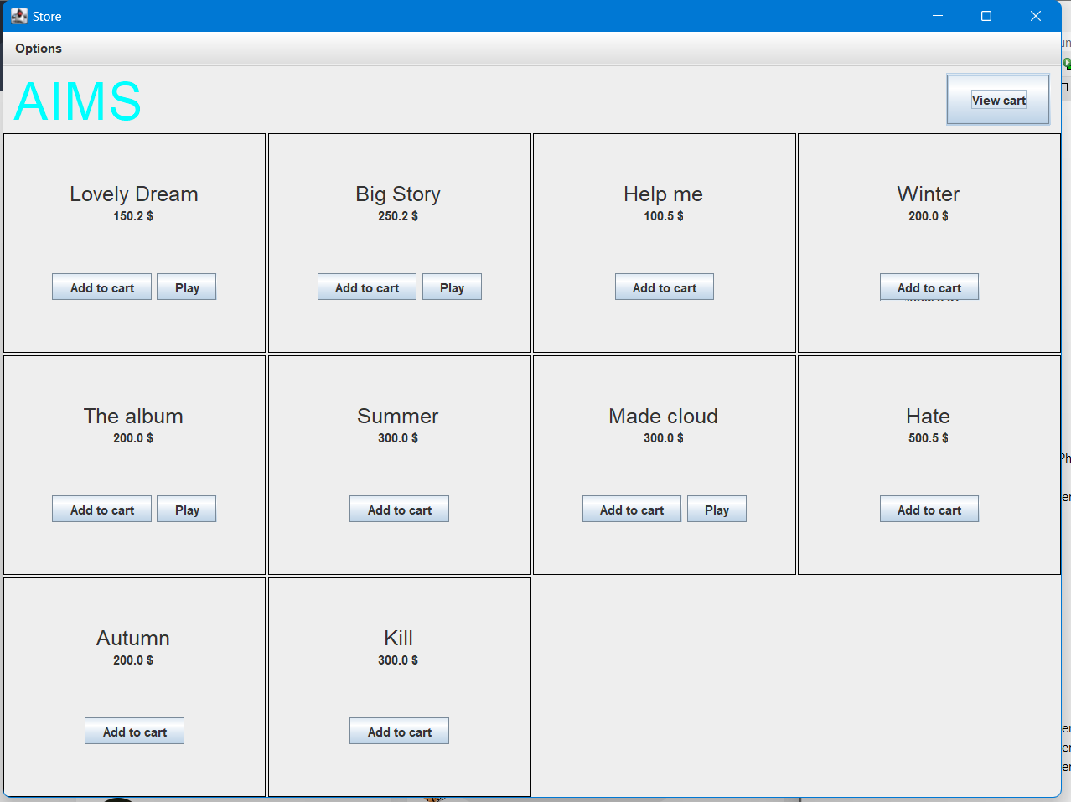

* Play the Media

* Add to cart

1. View Cart Screen
   1. File Cart.fxml

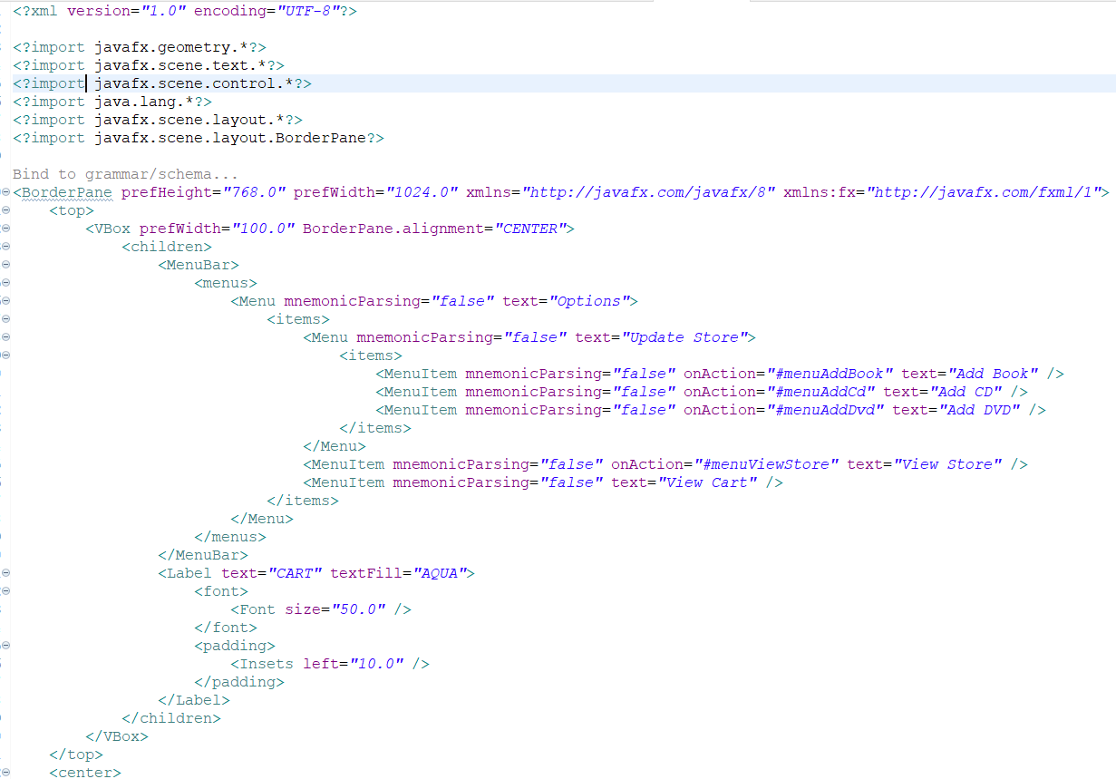

* 1. CartScreenController

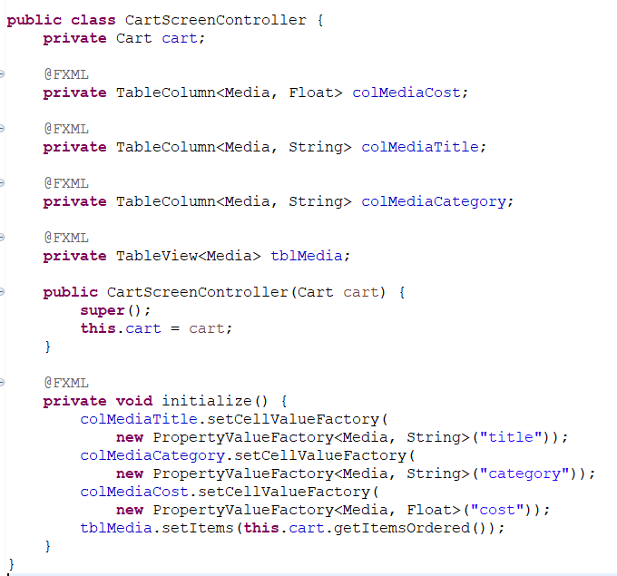

* 1. Thay đổi thuộc tính itemsOrdered



* 1. Demo

1. Update button TableView-ChangeListener

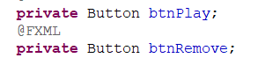

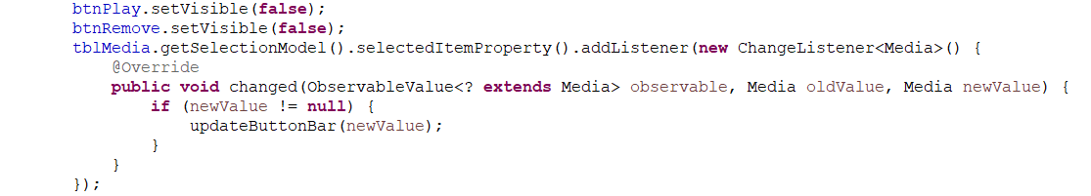

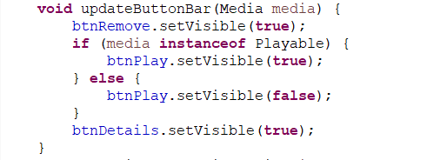

1. Remove Media button

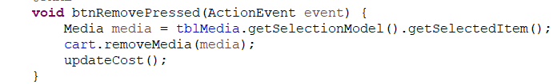

1. Filter items in cart – FilteredList

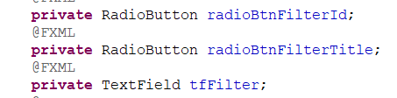

* Thêm ChangeListener cho tFilter

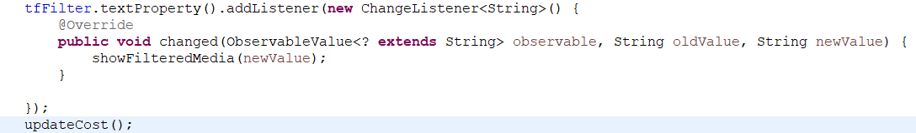

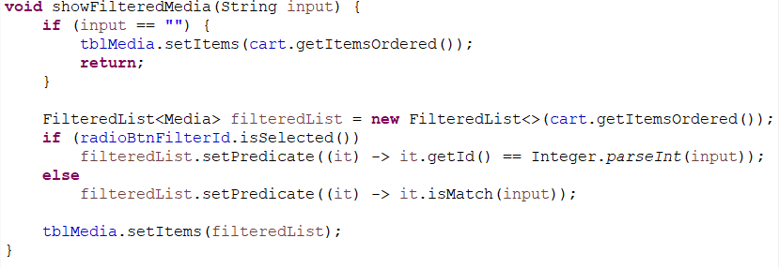

1. Complete UI cho Aims

* Tổng hợp code UI cho Aims được đặt ở package hust.soict.ite6.aims.screen
* Đối với ứng dụng AIMS, triển khai ba màn hình:
* Màn hình “View Store” sử dụng Swing.
* Màn hình “View Cart” sử dụng JavaFX.
* Màn hình “Update Store” gồm “add book”, “add dvd”, “add CD” sử dụng Swing.
  1. Class StoreScreen

* 1. Class MediaStore

* 1. CartScreen

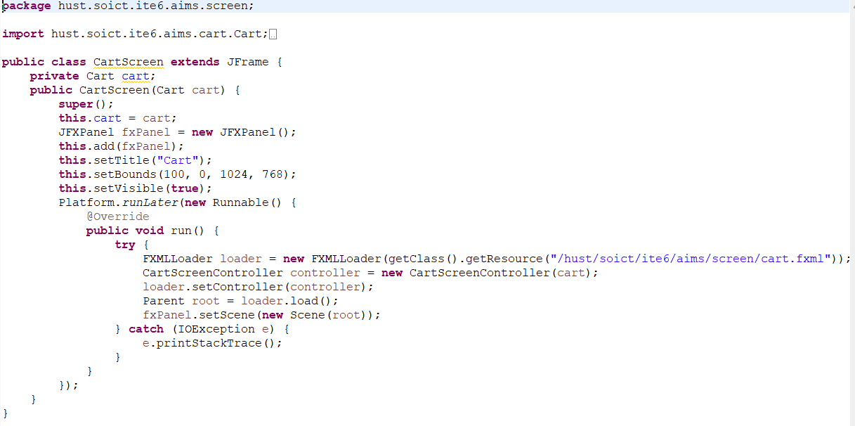

* 1. CartScreenController

* 1. DetailScreen

* 1. PlaceOrderScreen

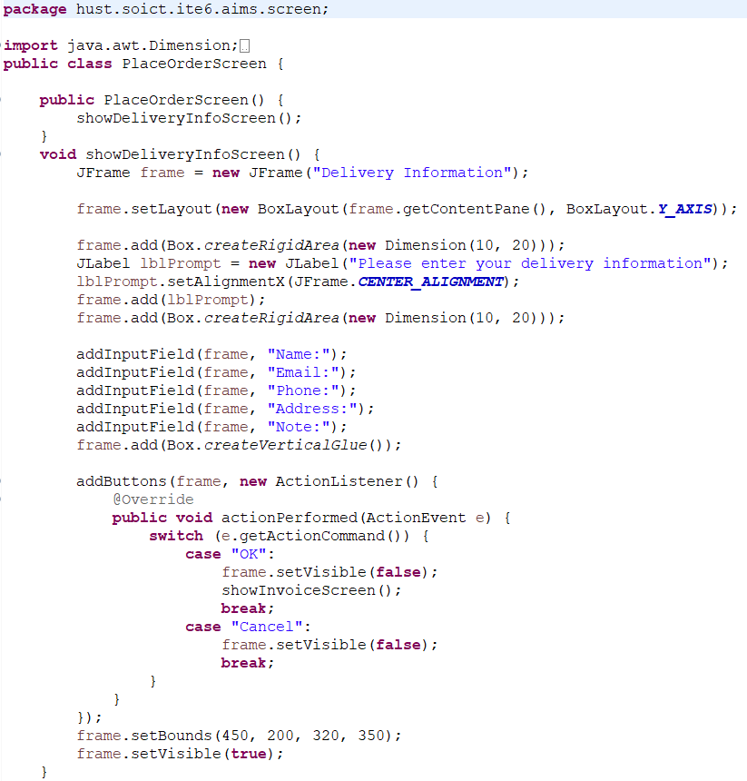

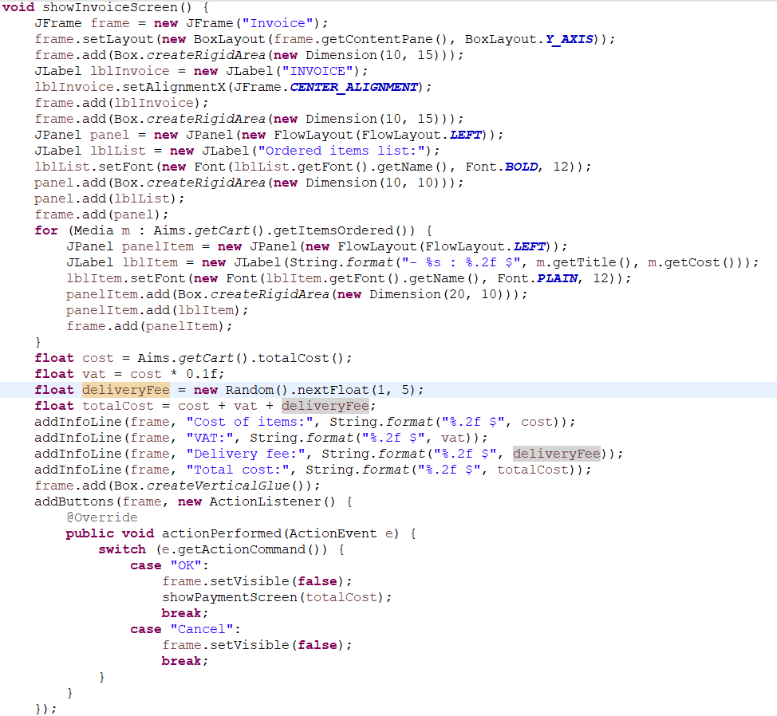

* 1. AddBookToStoreScreen

* 1. AddCompactDiscToStoreScreen

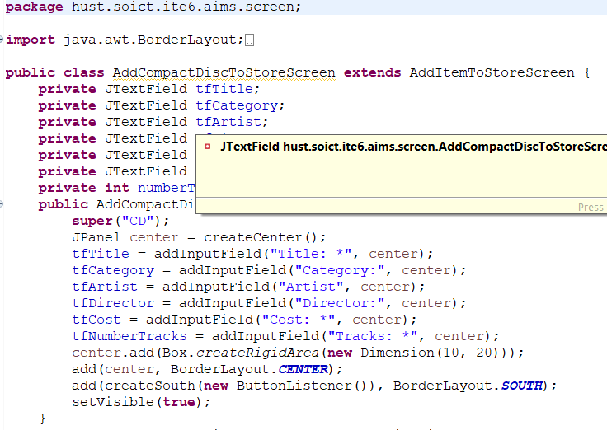

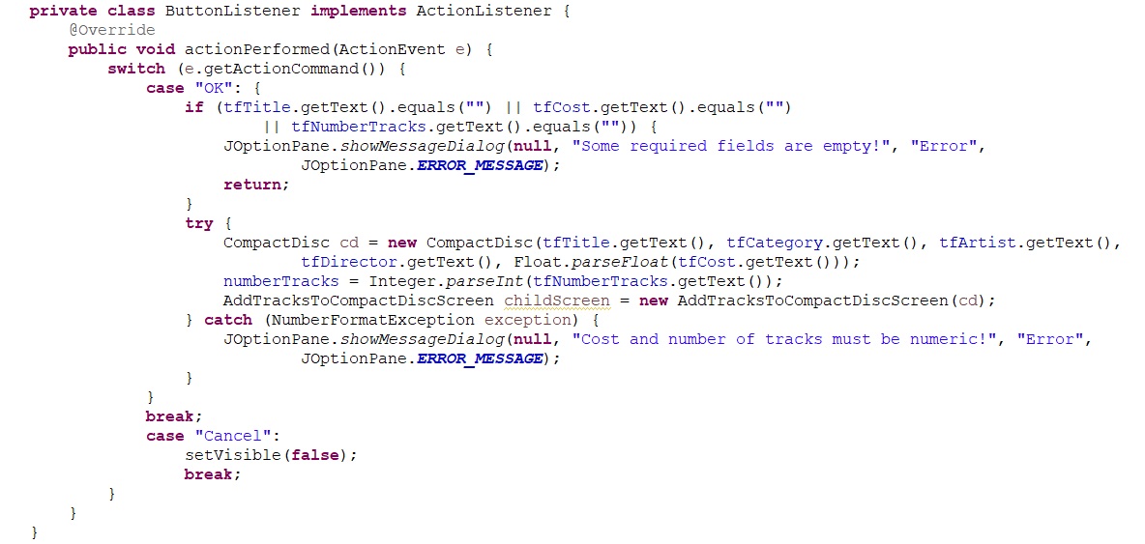

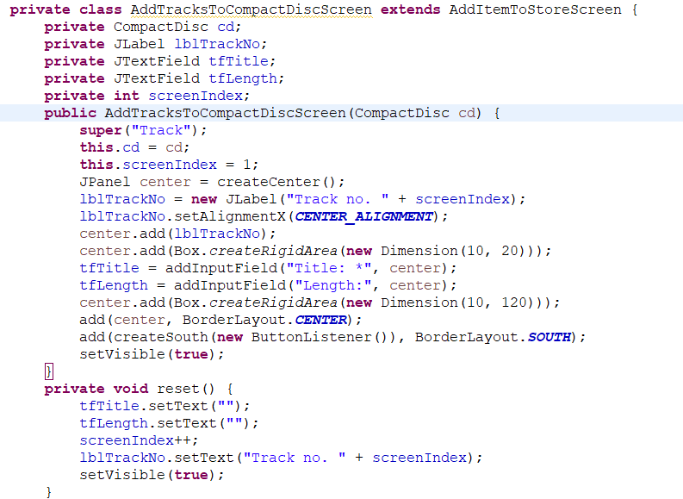

* 1. AddDigitalVideoDiscToStoreScreen

* 1. AddItemToStoreScreen

* 1. PlaceOrderScreen

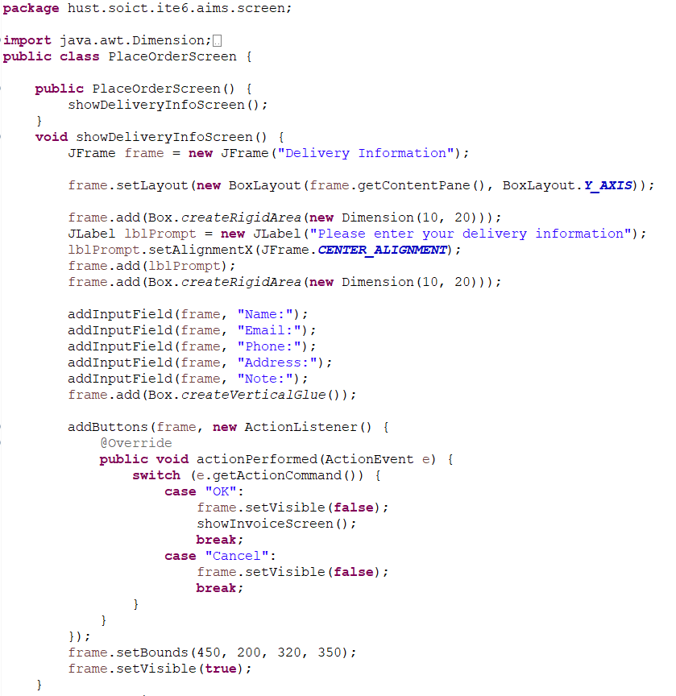

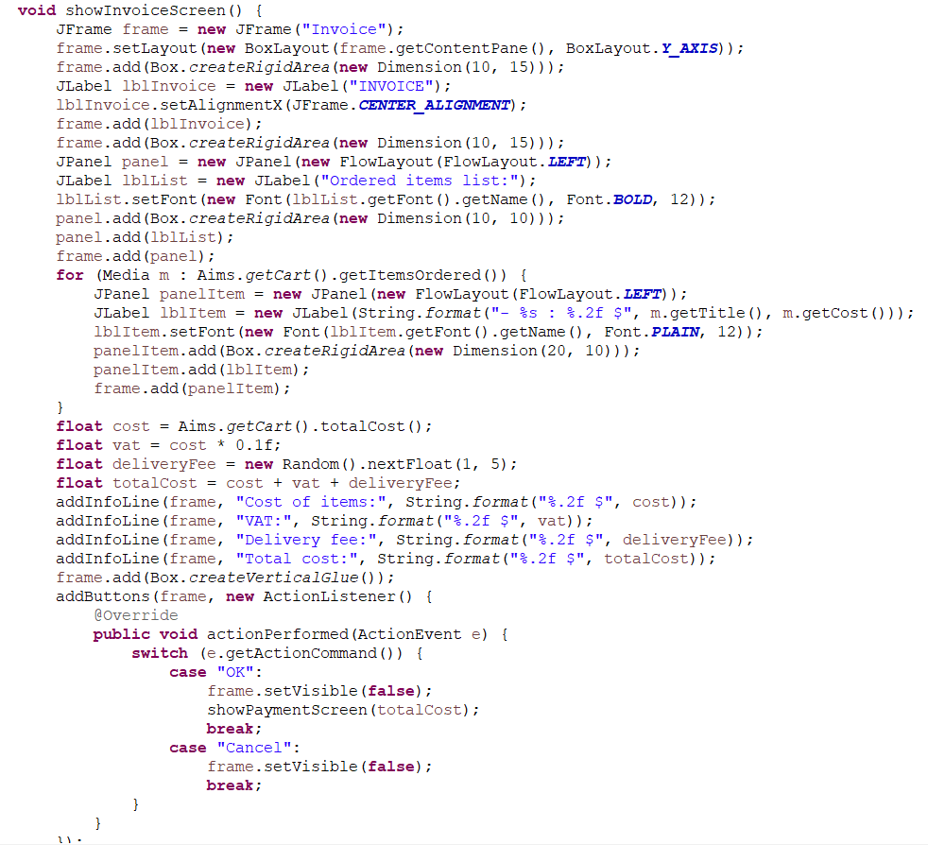

* 1. Chỉnh lại class Aims để chạy UI.

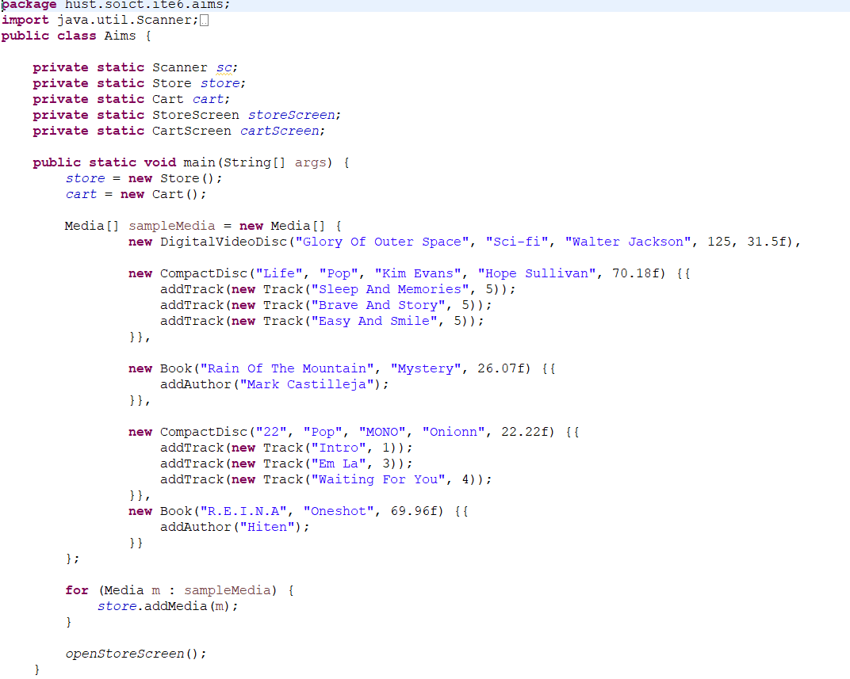

* Chỉnh lại các file còn lại trong project aims để hợp với UI trên trong souce code trên git.

1. Exception
   1. File DuplicatedItemException

* 1. File PlayerException

1. Modify the equals() method of Media Class

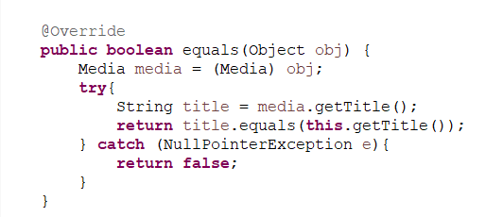

1. Demo the complete aims GUI application

Chạy trong code

1. Update Aims Class diagram

